

Fly Away Plus

Screen Design

**Project Code: FAP**

**Document Code: FAP _ Screen Design_v1.0_EN**

**Ha Noi, 13/06/2015**

Record of change

*A - Added M - Modified D – Deleted

|  |  |  |  |  |
| --- | --- | --- | --- | --- |
| **Effective Date** | **Changed Items** | **A* M, D** | **Change Description** | **New Version** |
|  |  |  |  |  |
|  |  |  |  |  |
|  |  |  |  |  |

**Signature page**

**Riginator** Duong Thanh Hai 13/06/2015

Developer

**Reviewer**  Hoang Nghia Duc 14/06/2015

Project Manager

**Approval** Nguyen Van Sang 14/06/2015

Supervisor

Table of Contents

1 Introduction 4

*1.1* Purpose 4

*1.2* Definitions, Acronyms and Abbreviations 4

*1.3* Overview 4

2 Screen Flow 5

*2.1* Search screen 5

*2.2* Login 6

*2.3* Register 7

*2.4* Edit profile 9

*2.5* Forgot password 10

*2.6* Contribute content 11

*2.7* Contribute opinion 12

*2.8* Send Q&A 13

*2.9* Test 14

*2.10* Training listening 15

*2.11* Conversation 17

*2.12* Reading 19

*2.13* Management Member’s account 19

*2.14* Vocabulary management 20

*2.15* Grammar management 21

*2.16* Conversation management 22

*2.17* Video management 23

*2.18* Listening article management 24

*2.19* Doing test management 25

*2.20* Search contribute content 26

*2.21* Approve contribute content 29

*2.22* Contribute opinion management 32

3 Other considerations 33

# Introduction

## Purpose

To ensure consistency and simplicity in detailed design across all displays within a product interface, as well as across other products used by the same users. Definitions, acronyms, abbreviations, references and overview of FAP website

## Definitions, Acronyms and Abbreviations

|  |  |  |
| --- | --- | --- |
| Abbreviations | Description | Comment |
| FAP | Fly Away Plus | Social network of travelling |
| Q&A | Question and answer |  |
|  |  |  |
|  |  |  |

## Overview

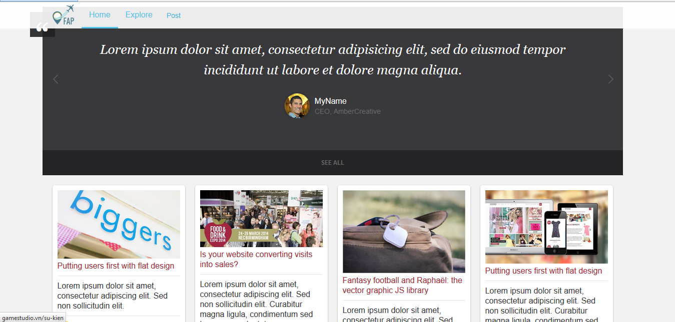

# Screen Flow



|  |  |  |
| --- | --- | --- |
| No | Screen Name | Description |
| 1 | Homepage | Homepage |
| 2 | Contact | Contact to admin |
| 3 | Login | Login as a member |
| 4 | Register | Create New Account |
| 5 | ForgotPassword | Receive new password |
| 6 | LookAround | Search around near current position |
| 7 | UserDetail | Timeline and information of user |
| 8 | Search | Search result |
| 9 | RoomList | List room |
| 10 | SearchDetail | Detail information of place |
| 11 | RoomDetail | Detail information of room |
| 12 | PostDetail | Detail information of post |

## Home page

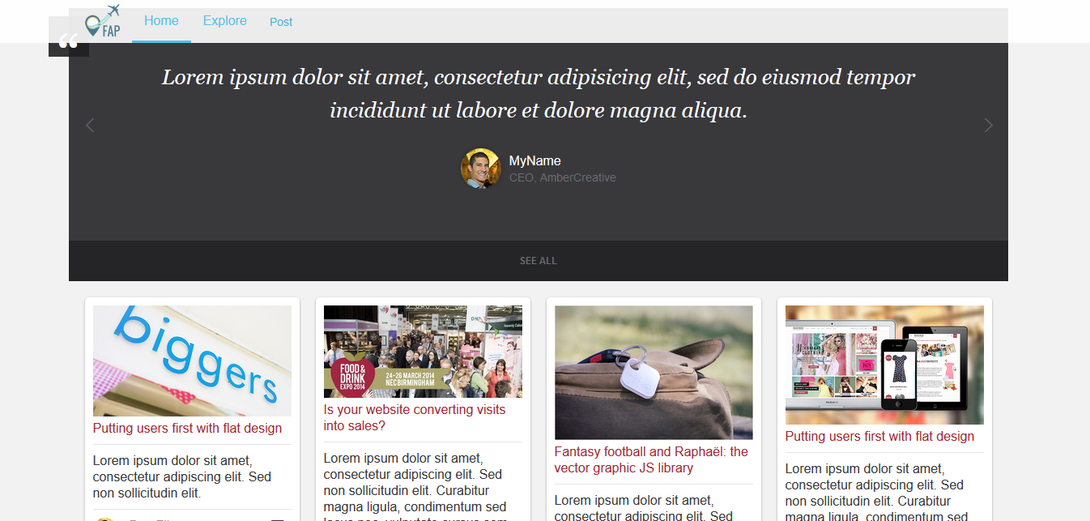

Figure 1: Home page

|  |  |  |  |  |  |  |  |
| --- | --- | --- | --- | --- | --- | --- | --- |
| **No** | **Field name** | **Field name in Vietnamese** | **Type** | **Require** | **Mandatory** | **Max-Length** | **Description** |
| 1 | Logo | Logo | Image | Image | Y |  | Logo of FAP website |
| 2 | Home | Trang chủ | Button | Click | Y |  | Redirect to home page |
| 3 | Post | Đăng bài | Button | Click | Y |  | User want to post a new post |
| 4 | List Post | Danh sách các bài post | List |  |  |  | Show list of post |
| Table 1: Home page description | | | | | | | |

## Login

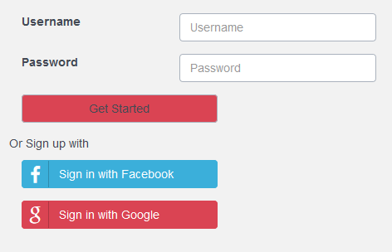

Figure 2.1: Login

|  |  |  |  |  |  |  |  |
| --- | --- | --- | --- | --- | --- | --- | --- |
| **No** | **Field name** | **Field name in Vietnamese** | **Type** | **Require** | **Mandatory** | **Max-Length** | **Description** |
| 1 | Username | Tên đăng nhập | Text | Text | Y | 32 | User input username with length less than 32 character |
| 2 | Password | Mật khẩu | Password | Text | Y | 32 | User input their password with length less than 32 characters |
| 3 | Get Start | Đăng nhập | Button | Click | Y |  | User click on Login button |
| 4 | Sign in with Facebook | Đăng nhập bằng tài khoản Facebook | Button | Click | Y |  | User click to login with Facebook account |
| 5 | Sign in with Google | Đăng nhập bằng tài khoản Google | Button | Click | Y |  | User click to login with Google Account |
| Table 2.1: Login’s screen description | | | | | | | |

## Register

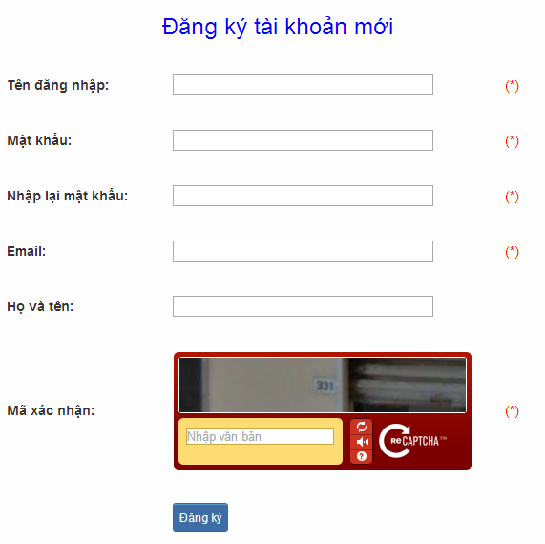

Figure 2.3: Register

|  |  |  |  |  |  |  |  |
| --- | --- | --- | --- | --- | --- | --- | --- |
| **No** | **Field name** | **Field name in Vietnamese** | **Type** | **Require** | **Mandatory** | **Max-Length** | **Description** |
| 1 | Username | Tên đăng nhập | Text | Text | Y | 32 | User input username with length less than 32 characters |
| 2 | Password | Mật khẩu | Password | Text | Y | 32 | User input their password with length less than 32 characters |
| 3 | Re-password | Nhập lại mật khẩu | Password | Text | Y | 32 | User re-input password with length less than 32 characters |
| 4 | Name | Họ và tên | Text | Text | Y | 100 | User input their name with length less than 100 characters |
| 5 | Email | Email | Text | Text | Y | 100 | User input email with length less than 32 characters |
| 6 | Capcha | Mã xác nhận | Text | Text | Y |  | User input the verification code |
| 7 | Register | Đăng ký | Button | Click | Y |  | User click Register button |
| Table 2.3: Register’s screen description | | | | | | | |

## Edit profile

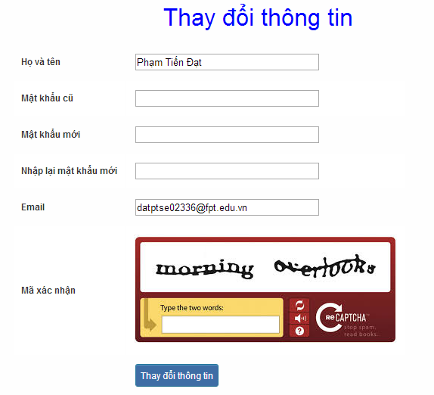

Figure 2.4: Edit profile

|  |  |  |  |  |  |  |  |
| --- | --- | --- | --- | --- | --- | --- | --- |
| **No** | **Field name** | **Field name in Vietnamese** | **Type** | **Require** | **Mandatory** | **Max-Length** | **Description** |
| 1 | Name | Họ và tên | Text | Text | Y | 100 | User input their name with length less than 100 characters |
| 2 | Old-Password | Mật khẩu cũ | Password | Text | Y | 32 | User input their old password with length less than 32 characters |
| 3 | New-password | Mật khẩu mới | Password | Text | Y | 32 | User input new password with length less than 32 characters |
| 4 | Re-password | Nhập lại mật khẩu mới | Password | Text | Y | 32 | User re-input password with length less than 32 characters |
| 5 | Email | Email | Text | Text | Y | 100 | User input email to with length less than 100 characters |
| 6 | Capcha | Mã xác nhận | Text | Text | Y |  | User input the verification code |
| 7 | Edit | Thay đổi thông tin | Button | Click | Y |  | User click on Edit button |
| Table 2.4: Edit profile’s screen description | | | | | | | |

## Forgot password

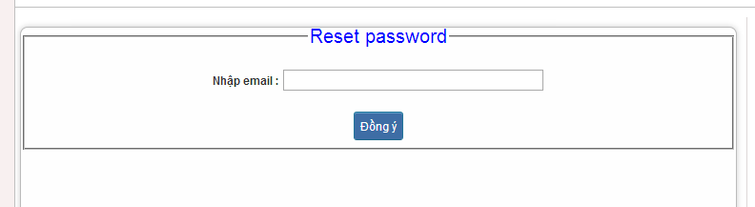

Figure 2.5: Forgot password

|  |  |  |  |  |  |  |  |
| --- | --- | --- | --- | --- | --- | --- | --- |
| **No** | **Field name** | **Field name in Vietnamese** | **Type** | **Require** | **Mandatory** | **Max-Length** | **Description** |
| 1 | Email | Email | Text | Text | Y | 100 | User input email with length less than 100 characters |
| 2 | Send | Đồng ý | Button | Click | Y |  | Click to receive password |
| Table 2.5: Forgot password’s screen description | | | | | | | |

## Contribute content

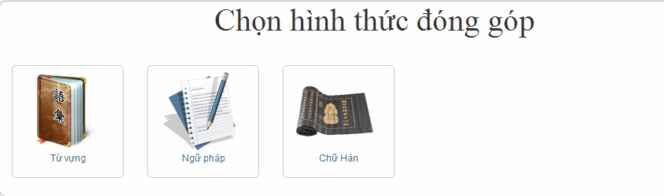

Figure 3.1: Contribute content

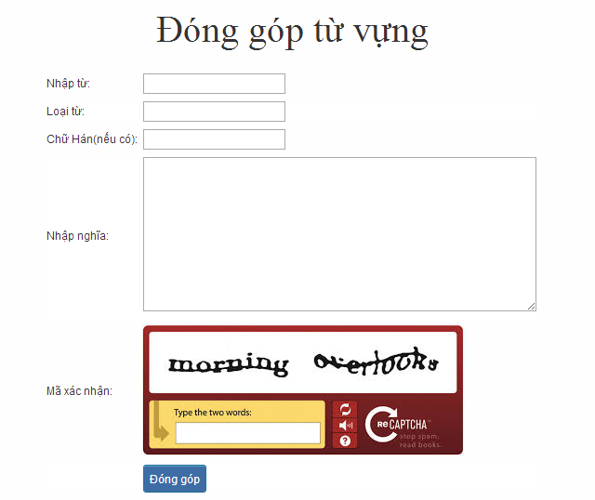

Figure 3.1.1: Contribute vocabulary

|  |  |  |  |  |  |  |  |
| --- | --- | --- | --- | --- | --- | --- | --- |
| **No** | **Field name** | **Field name in Vietnamese** | **Type** | **Require** | **Mandatory** | **Max-Length** | **Description** |
| 1 | Vocabulary | Từ | Text | Text | Y | 200 | User input vocabulary with length less than 200 characters |
| 2 | Category | Loại từ | Drop-down list | Click | Y |  | User choose type of category |
| 3 | Kanji | Chữ Hán | Text | Text | Y | 10 | User input kanji of vocabulary (if exist) with length less than 10 characters |
| 4 | Mean | Nhập nghĩa | Text | Text | Y | 500 | User input mean of vocabulary with length less than 500 characters |
| 5 | Capcha | Mã xác nhận | Text | Text | Y |  | User input the verification code |
| 6 | Contribute | Đóng góp | Button | Click | Y |  | User click on contribute button |
| Table 3.1: Contribute vocabulary’s screen description | | | | | | | |

## Contribute opinion

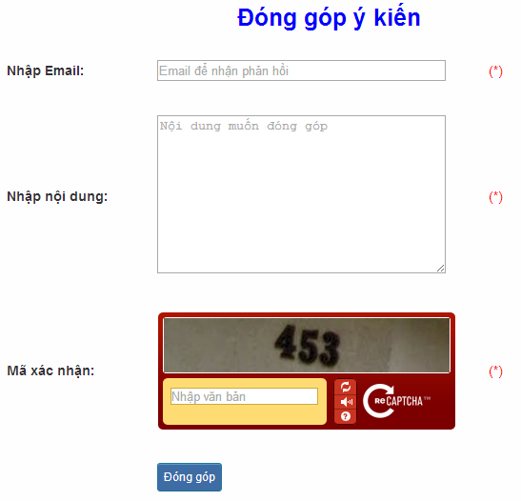

Figure 3.2: Contribute opinion

|  |  |  |  |  |  |  |  |
| --- | --- | --- | --- | --- | --- | --- | --- |
| **No** | **Field name** | **Field name in Vietnamese** | **Type** | **Require** | **Mandatory** | **Max-Length** | **Description** |
| 1 | Email | Email | Text | Text | Y | 100 | User input email with length less than100 characters |
| 2 | Content | Nhập nội dung | Text | Text | Y | 1000 | User input content with length less than1000 characters |
| 3 | Capcha | Mã xác nhận | Text | Text | Y |  | User input the verification code |
| 4 | Contribute | Đóng góp | Button | Click | Y |  | User click on contribute button |

Table 3.2: Contribute opinion’s screen description

## Send Q&A

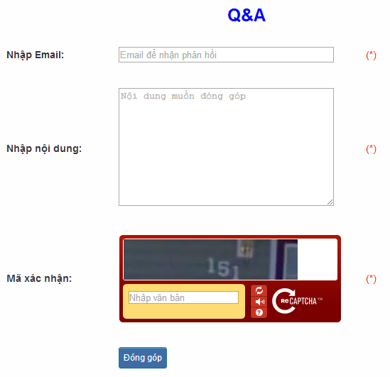

Figure 3.3: Send Q&A

|  |  |  |  |  |  |  |  |
| --- | --- | --- | --- | --- | --- | --- | --- |
| **No** | **Field name** | **Field name in Vietnamese** | **Type** | **Require** | **Mandatory** | **Max-Length** | **Description** |
| 1 | QA | Q&A | Text | Text | Y | 1000 | User input Q&A with length less than 1000 characters |
| 2 | Email | Email | Text | Text | Y | 100 | User input email with length less than 100 characters |
| 3 | Capcha | Mã xác nhận | Text | Text | Y |  | User input the verification code |
| 4 | Contribute | Đóng góp | Button | Click | Y |  | User click on contribute button |

Table 3.3: Send Q&A’s screen description

## Test

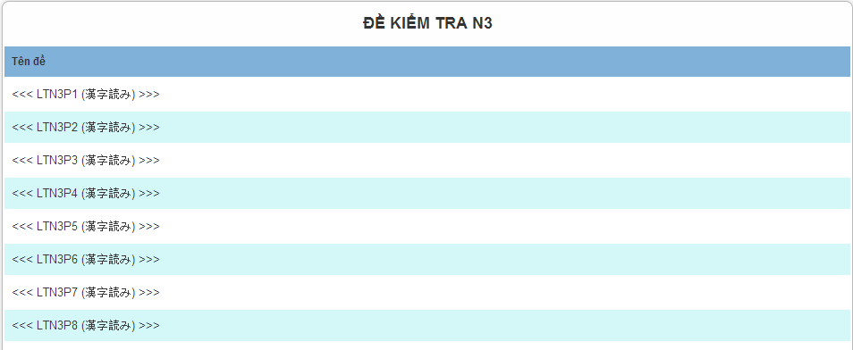

Figure 4.1: Doing test

|  |  |  |  |  |  |  |
| --- | --- | --- | --- | --- | --- | --- |
| **No** | **Field name** | **Type** | **Require** | **Mandatory** | **Length** | **Description** |
| 1 | N3P1 | Hyperlink | Click | N |  | Display information of test |
| 2 | N3P2 | Hyperlink | Click | N |  | Display information of test |
| 3 | N3P3 | Hyperlink | Click | N |  | Display information of test |
| 4 | N3P4 | Hyperlink | Click | N |  | Display information of test |
|  |  |  |  |  |  |  |

## Training listening

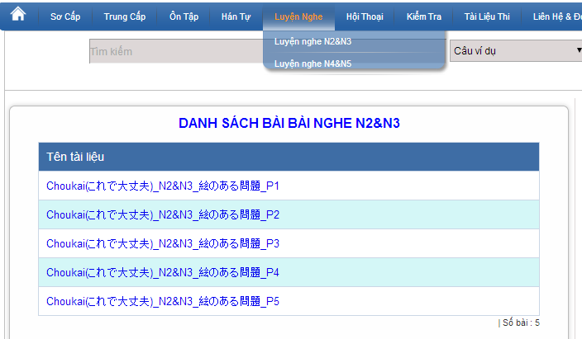

Figure 4.2: Training listening

|  |  |  |  |  |  |  |
| --- | --- | --- | --- | --- | --- | --- |
| **No** | **Field name** | **Type** | **Require** | **Mandatory** | **Length** | **Description** |
| 1 | Choukai_P1 | Hyperlink | Click | N |  | Display information of listening |
| 2 | Choukai_P2 | Hyperlink | Click | N |  | Display information of listening |
| 3 | Choukai_P3 | Hyperlink | Click | N |  | Display information of listening |
| 4 | Choukai_P4 | Hyperlink | Click | N |  | Display information of listening |
| 5 | Choukai_P5 | Hyperlink | Click | N |  | Display information of listening |

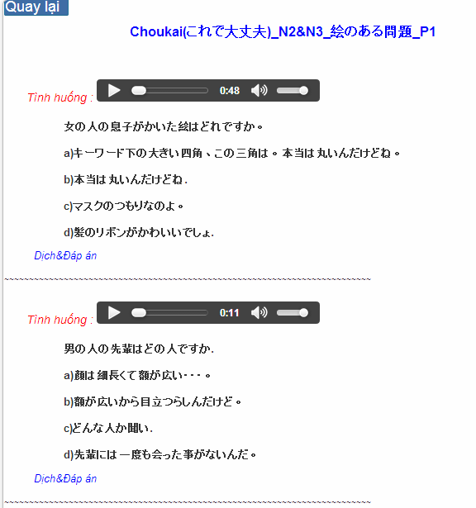

Figure 4.2.1: Training listening content

|  |  |  |  |  |  |  |
| --- | --- | --- | --- | --- | --- | --- |
| **No** | **Field name** | **Field name in Vietnamese** | **Type** | **Require** | **Mandatory** | **Description** |
| 1 | Audio | Audio | Audio | Click | Y | User click play button |
| 2 | Translation and Answer | Dịch và đáp án | Link | Click | Y | User click to display translation and answer |

Table 4.2.1: Training listening content’s screen description

## Conversation

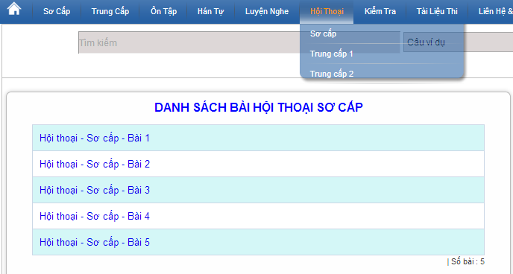

Figure 4.3: Conversation

|  |  |  |  |  |  |  |
| --- | --- | --- | --- | --- | --- | --- |
| **No** | **Field name** | **Type** | **Require** | **Mandatory** | **Length** | **Description** |
| 1 | SC_P1 | Hyperlink | Click | N |  | Display information of conversation |
| 2 | SC_P2 | Hyperlink | Click | N |  | Display information of conversation |
| 3 | SC_P3 | Hyperlink | Click | N |  | Display information of conversation |
| 4 | SC_P4 | Hyperlink | Click | N |  | Display information of conversation |
| 5 | SC_P5 | Hyperlink | Click | N |  | Display information of conversation |

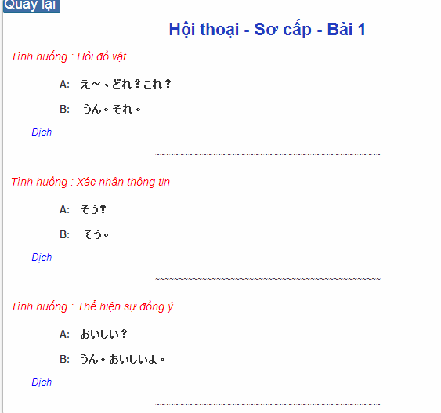

Figure 4.3.1: Conversation content

|  |  |  |  |  |  |  |
| --- | --- | --- | --- | --- | --- | --- |
| **No** | **Field name** | **Field name in Vietnamese** | **Type** | **Require** | **Mandatory** | **Description** |
| 1 | Translation | Dịch | Link | Click | Y | User click to display translation |

Table 4.2.1: Training listening content’s screen description

## Reading

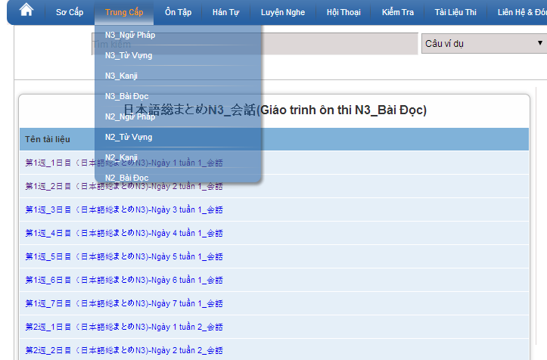

Figure 4.4: Reading document

## Management Member’s account

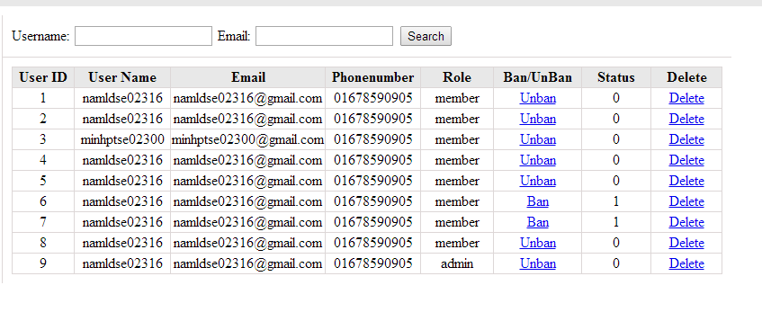

Figure 6: Management Member

|  |  |  |  |  |  |  |
| --- | --- | --- | --- | --- | --- | --- |
| **No** | **Field name** | **Type** | **Require** | **Mandatory** | **Max-Length** | **Description** |
| 1 | Username | Text | Text | Y | 32 | Admin input username to search member by username |
| 2 | Email | Text | Text | Y | 100 | Admin input email to search member by email |
| 3 | Ban/Unban | Button | Click | N |  | Admin click ban/unban member |
| 4 | Delete | Button | Click | N |  | Admin click delete member |

Table 6: Management member’s screen description

## Vocabulary management

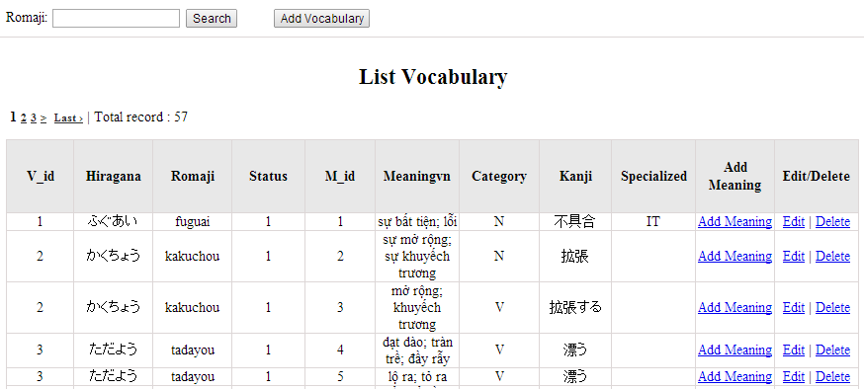

Figure 7: Vocabulary management

|  |  |  |  |  |  |  |
| --- | --- | --- | --- | --- | --- | --- |
| **No** | **Field name** | **Type** | **Require** | **Mandatory** | **Max-Length** | **Description** |
| 1 | Romaji | Text | Text | Y | 100 | Admin input romaji with length less than 100 character |
| 2 | Addnew | Button | Click | N |  | Admin add new vocabulary into database |
| 3 | Add meaning | Button | Click | Y |  | Admin add meaning of vocabulary |
| 4 | Edit | Button | Click | N |  | Admin click edit vocabulary |
| 5 | Delete | Button | Click | N |  | Admin click delete vocabulary |

Table 7.1: Vocabulary management’s screen description

## Grammar management

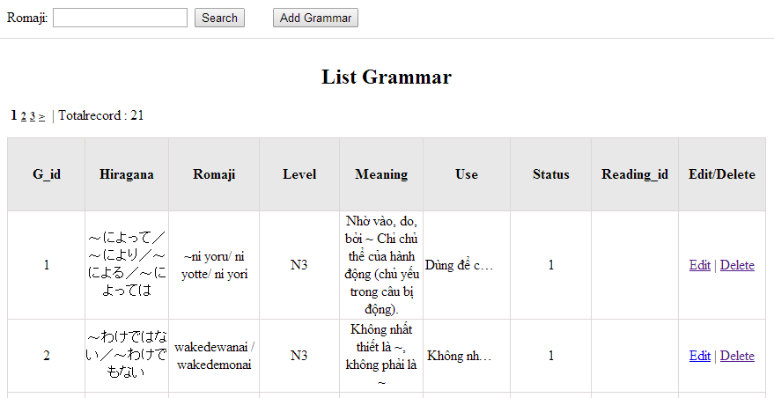

Figrure 8: Grammar management

|  |  |  |  |  |  |  |
| --- | --- | --- | --- | --- | --- | --- |
| **No** | **Field name** | **Type** | **Require** | **Mandatory** | **Max-Length** | **Description** |
| 1 | Romaji | Text | Text | Y | 100 | Admin input romaji with length less than 100 character |
| 2 | Addnew | Button | Click | N |  | Admin add new grammar into database |
| 3 | Edit | Button | Click | N |  | Admin click edit grammar |
| 4 | Delete | Button | Click | N |  | Admin click delete grammar |

Table 8.1: Grammar management’s screen description

## Conversation management

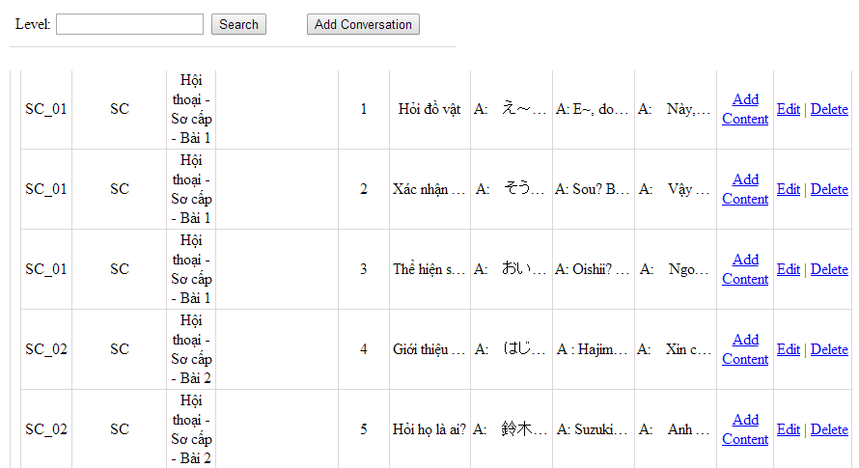

Figure 10: Conversation management

|  |  |  |  |  |  |  |
| --- | --- | --- | --- | --- | --- | --- |
| **No** | **Field name** | **Type** | **Require** | **Mandatory** | **Max-Length** | **Description** |
| 1 | Level | Text | Text | Y | 100 | Admin input level with length less than 100 characters |
| 2 | Addnew | Button | Click | N |  | Admin add new conversation into database |
| 3 | Add content | Button | Click | Y |  | Admin input content of conversation |
| 4 | Edit | Button | Click | N |  | Admin click edit conversation |
| 5 | Delete | Button | Click | N |  | Admin click delete conversation |

Table 10.1: Conversation management’s screen description

## Video management

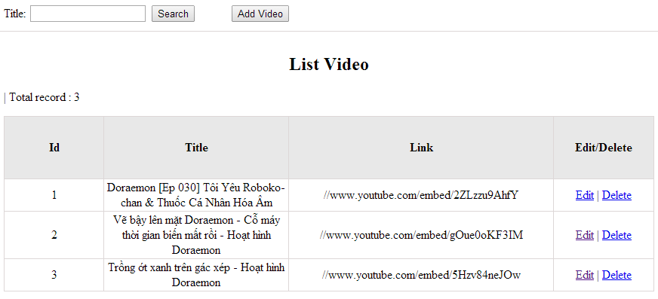

Figure 11: Video management

|  |  |  |  |  |  |  |
| --- | --- | --- | --- | --- | --- | --- |
| **No** | **Field name** | **Type** | **Require** | **Mandatory** | **Max-Length** | **Description** |
| 1 | Title | Text | Text | Y | 100 | Admin input title with length less than 100 character |
| 2 | Addnew | Button | Click | N |  | Admin add new video into database |
| 3 | Edit | Button | Click | N |  | Admin click edit video |
| 4 | Delete | Button | Click | N |  | Admin click delete video |
| Table 11.1: Video management’s screen description | | | | | | |

## Listening article management

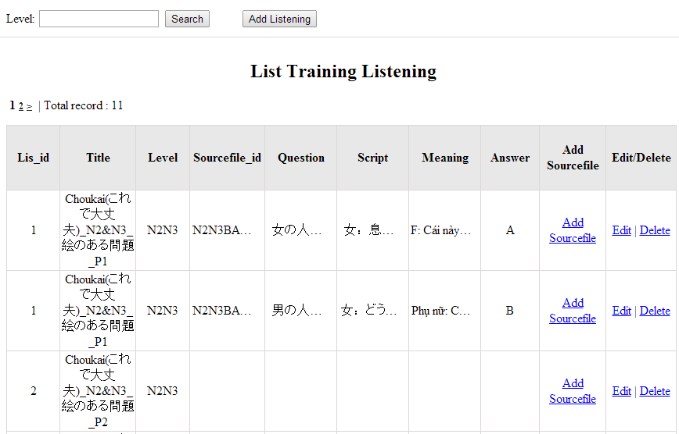

Figure 12: Listening article management

|  |  |  |  |  |  |  |
| --- | --- | --- | --- | --- | --- | --- |
| **No** | **Field name** | **Type** | **Require** | **Mandatory** | **Max-Length** | **Description** |
| 1 | Level | Text | Text | Y | 100 | Admin input level with length less than 100 characters |
| 2 | Addnew | Button | Click | N |  | Admin add new listening article into database |
| 3 | Add source | Button | Click | Y |  | Admin input source file |
| 4 | Edit | Button | Click | N |  | Admin click edit listening article |
| 5 | Delete | Button | Click | N |  | Admin click delete article |
| Table 12.1: Conversation management’s screen description | | | | | | |

## Doing test management

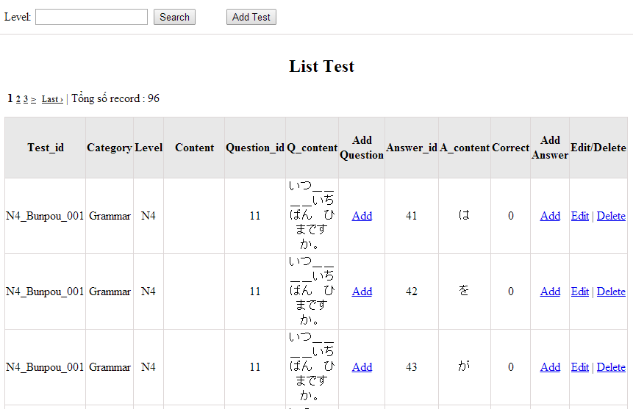

Figure 13: Doing test management

|  |  |  |  |  |  |  |
| --- | --- | --- | --- | --- | --- | --- |
| **No** | **Field name** | **Type** | **Require** | **Mandatory** | **Max-Length** | **Description** |
| 1 | Level | Text | Text | Y | 100 | Admin input level |
| 2 | Add new test | Button | Click | N |  | Admin add new test into database |
| 3 | Add question | Button | Click | N |  | Admin add question |
| 4 | Add answer | Button | Click | N |  | Admin add answer |
| 4 | Edit | Button | Click | N |  | Admin click edit test |
| 5 | Delete | Button | Click | N |  | Admin click delete test |

Table 13.1: Doing test management’s screen description

## Search contribute content

1. Contribute kanji screen:

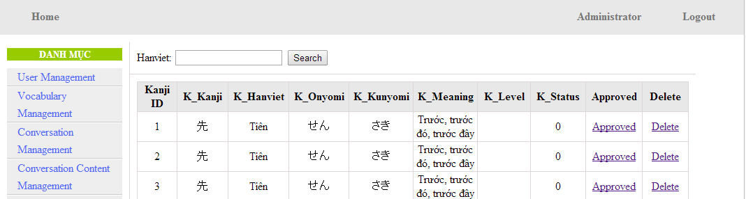

Figure 14.1: Contribute kanji’s screen

|  |  |  |  |  |  |  |
| --- | --- | --- | --- | --- | --- | --- |
| **No** | **Field name** | **Type** | **Require** | **Mandatory** | **Max-Length** | **Description** |
| 1 | HanViet | Text | Text | Y | 100 | Admin input to search |
| 2 | Approved | Button | Click | N |  | Admin click to approved contribute |
| 3 | Delete | Button | Click | N |  | Admin click delete contribute |

Table 14.1: Contribute kanji’s screen description

1. Contribute grammar screen:

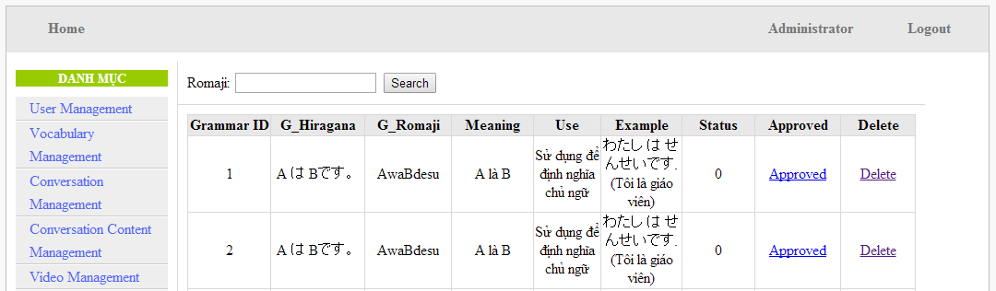

Figure 14.2: Contribute grammar’ screen:

|  |  |  |  |  |  |  |
| --- | --- | --- | --- | --- | --- | --- |
| **No** | **Field name** | **Type** | **Require** | **Mandatory** | **Max-Length** | **Description** |
| 1 | Romaji | Text | Text | Y | 100 | Admin input to search |
| 2 | Approved | Button | Click | N |  | Admin click to approved contribute |
| 3 | Delete | Button | Click | N |  | Admin click delete contribute |

Table 14.2: Contribute grammar’ screen description

1. Contribute vocabulary screen:

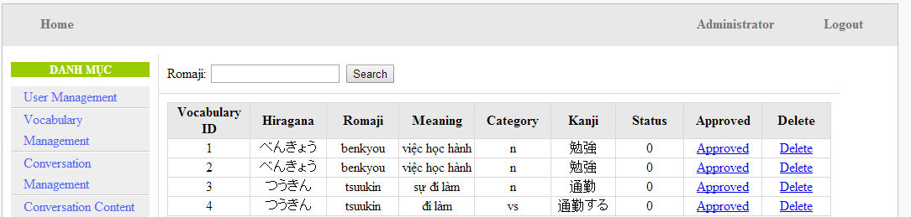

Figure 14.3: Contribute vocabulary screen

|  |  |  |  |  |  |  |
| --- | --- | --- | --- | --- | --- | --- |
| **No** | **Field name** | **Type** | **Require** | **Mandatory** | **Max-Length** | **Description** |
| 1 | Romaji | Text | Text | Y | 100 | Admin input to search |
| 2 | Approved | Button | Click | N |  | Admin click to approved contribute |
| 3 | Delete | Button | Click | N |  | Admin click delete contribute |

Table 14.3: Contribute vocabulary screen description

## Approve contribute content

1. Approve contribute kanji screen:

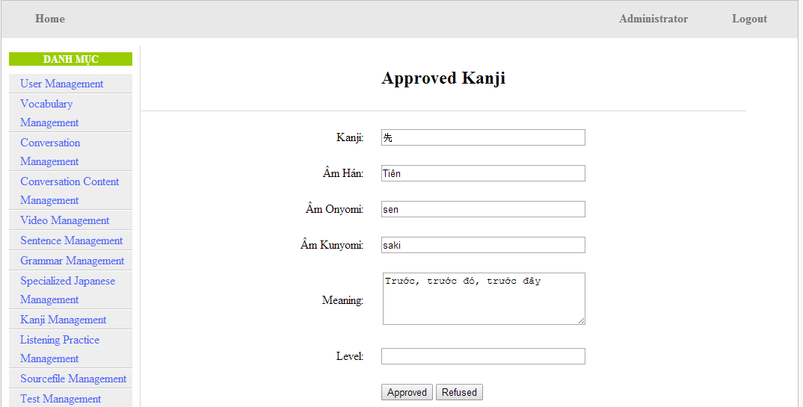

Figure 15.1: Approved kanji’s screen

|  |  |  |  |  |  |  |  |
| --- | --- | --- | --- | --- | --- | --- | --- |
| **No** | **Field name** | **File name in Vietnamese** | **Type** | **Require** | **Mandatory** | **Max-Length** | **Description** |
| 1 | Kanji | Kanji | Text | Text | Y | 10 | Admin input kanji |
| 2 | AmHan | Âm hán | Text | Text | N | 50 | Admin input to the field |
| 3 | Onyomi | Âm Onyomi | Text | Text | Y | 100 | Admin input onyomi |
| 4 | Kunyomi | Âm kunyomi | Text | Text | Y | 100 | Admin input kunyomi |
| 5 | Meaning | Nghĩa | Text | Text | Y | 200 | Admin input meaning |
| 6 | Level | Level | Text | Text | Y | 10 | Admin choose the level |
| 7 | Approved | Approved | Button | Click | N |  | Admin click to approved contribute |
| 8 | Refuse | Refuse | Button | Click | N |  | Admin click to refuse contribute |

Table 15.1: Approved kanji’s screen description

1. Approve contribute grammar screen:

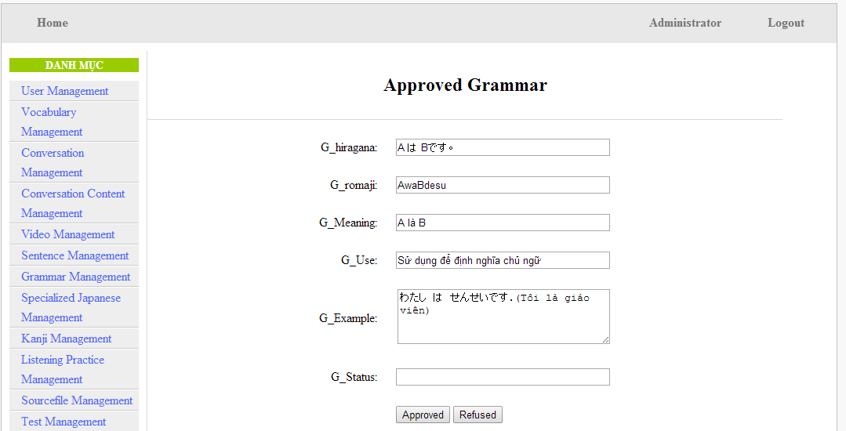

Figure 15.2: Approved grammar screen

|  |  |  |  |  |  |  |
| --- | --- | --- | --- | --- | --- | --- |
| **No** | **Field name** | **Type** | **Require** | **Mandatory** | **Max-Length** | **Description** |
| 1 | Hiragana | Text | Text | Y | 200 | Admin input hiragana |
| 2 | Romaji | Text | Text | N | 200 | Admin input romaji |
| 3 | Meaning | Text | Text | Y | 200 | Admin input meaning |
| 4 | Use | Text | Text | Y | 100 | Admin input kunyomi |
| 5 | Example | Text | Text | Y | 200 | Admin input meaning |
| 6 | Level | Text | Text | Y | 10 | Admin input level of grammar |
| 7 | Approved | Button | Click | N |  | Admin click to approved contribute |
| 8 | Refuse | Button | Click | N |  | Admin click to refuse contribute |

Table 15.2: Approved grammar’s screen description

1. Approve contribute vocabulary screen:

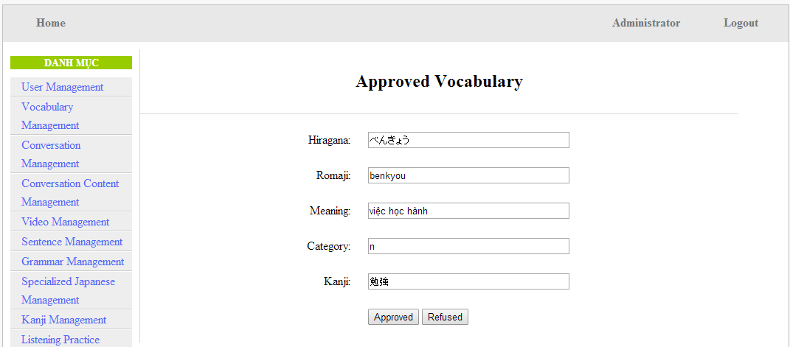

Table 15.3: Approved vocabulary

|  |  |  |  |  |  |  |
| --- | --- | --- | --- | --- | --- | --- |
| **No** | **Field name** | **Type** | **Require** | **Mandatory** | **Max-Length** | **Description** |
| 1 | Hiragana | Text | Text | Y | 200 | Admin input hiragana |
| 2 | Romaji | Text | Text | N | 200 | Admin input romaji |
| 3 | Meaning | Text | Text | Y | 500 | Admin input meaning |
| 4 | Category | Text | Text | Y | 10 | Admin choose category |
| 5 | Kanji | Text | Text | Y | 10 | Admin input kanji |
| 6 | Approved | Button | Click | N |  | Admin click to approved contribute |
| 7 | Refuse | Button | Click | N |  | Admin click to refuse contribute |

Table 15.3: Approved vocabulary’s screen description

## Contribute opinion management

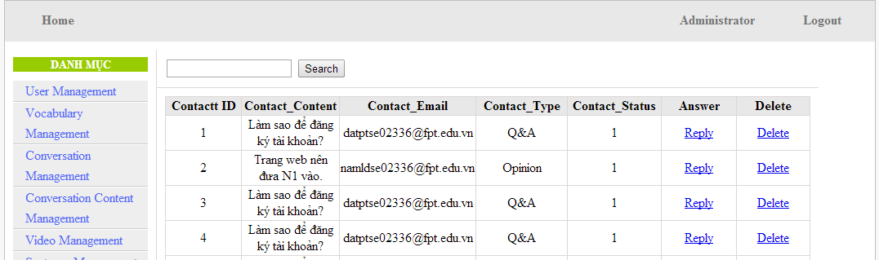

Figure 16: Contribute opinion management’s screen

|  |  |  |  |  |  |  |
| --- | --- | --- | --- | --- | --- | --- |
| **No** | **Field name** | **Type** | **Require** | **Mandatory** | **Max-Length** | **Description** |
| 1 | Reply | Button | Click | N |  | Admin click reply the question |
| 2 | Delete | Button | Click | N |  | Admin click delete question |

Table 16: Contribute opinion management’s screen description

# Other considerations

**N/A**